«${currentDate?date?string('dd MMMM yyyy'»
MyCCA reference: «${workflow.requestId}»

Operator name: «${params.targetUnitDetails.name}»
Company number: «${(params.targetUnitDetails.companyRegis»
Address for service:
By post:
«${params.targetUnitDetails.location}»
Electronically:
«${params.targetUnitDetails.primaryContac»

The Climate Change Agreements (Administration) Regulations 2012 (As amended) (“THE REGULATIONS”)

Dear «${params.targetUnitDetails.primaryContac»,

We are writing to inform «${params.targetUnitDetails.name}» (“you”) that the updates to information about the facilities in your underlying agreement were accepted on «${currentDate?date?string('dd MMMM yyyy'». This relates to the following underlying agreement and account reference:

Current Underlying Agreement Identifier(s): | «[#if (params.versionMap?keys?seq_contain»«${account.targetUnitIdentifier}» CCA2 Underlying Agreement «${params.versionMap["CCA2"]}»«[/#if]»«[#if (params.versionMap?keys?seq_contain», «[/#if]»«[#if (params.versionMap?keys?seq_contain»«${account.targetUnitIdentifier}» CCA3 Underlying Agreement «${params.versionMap["CCA3"]}»«[/#if]»
Target unit/account details: | «${account.targetUnitIdentifier}» –  «${params.targetUnitDetails.name}»  «${params.targetUnitDetails.targetUnitAdd»

The paragraph below summarises the changes we accepted to the facilities in your agreement:

«${params.additionalInformation}»

As the updates do not change any of the information in the existing version of your underlying agreement, we are not issuing a new version and do not need to seek your consent.

If you require any clarification of the above, please contact your Sector Association in the first instance.

If you need to contact the Administrator for any supporting information, please use the following email address: cca-help@environment-agency.gov.uk.

Yours faithfully
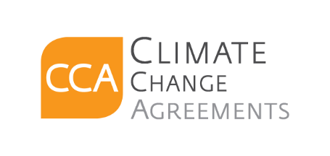
CCA Team

c.c. «[#list email.ccRecipients as cc]»«${cc}[#sep], [/#sep]»«[/#list]»

